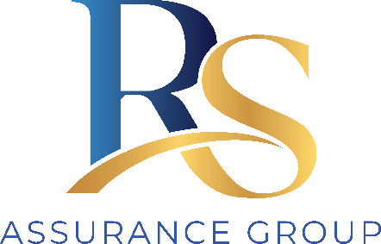
RS Assurance Group
Statement of Applicability
and Scope of Supports

Records the supports RS Assurance Group delivers, the registration groups sought, and which Practice Standards and modules apply to the audit.
Document ID | DOC-SOA-001
Version | 1.0 (draft for completion)
Prepared by | Ainim Support Services
Prepared for | RS Assurance Group
Approved by | [Name, Position]
Date | [DD/MM/YYYY]

Provider details
Legal / trading name | RS Assurance Group
ABN
NDIS registration status | ☐ Applying ☐ Registered — provider no.: __________
Registered office
States / territories of operation
Key contact for audit

Supports delivered and registration groups
List each registration group RS Assurance Group is registered for or applying for. The registration groups determine which standards and modules apply.
Group no. | Registration group | Audit type | Applies?
e.g. 0132 | Specialist Support Coordination | Certification | ☐
e.g. 0106 | Assist – Personal Activities | Certification | ☐
e.g. 0125 | Participate in Community | Certification | ☐
 |  |  | ☐
 |  |  | ☐
 |  |  | ☐
Examples above are illustrative only — replace with RS Assurance Group’s actual groups.

Module applicability
Module | Applies? | Basis / note
Core Module (all four standard areas) | Yes | Applies to all registered providers of these supports.
High Intensity Daily Personal Activities | ☐ Yes ☐ No | Applies only if delivering high-intensity personal care.
Specialist Behaviour Support | ☐ Yes ☐ No | Applies only if delivering behaviour support / regulated restrictive practices.
Implementing Behaviour Support Plans | ☐ Yes ☐ No | Applies only if implementing plans with restrictive practices.
Early Childhood Supports | ☐ Yes ☐ No | Applies only if delivering early childhood supports.
Specialised Support Coordination | ☐ Yes ☐ No | Applies if delivering specialised (Level 3) support coordination.
Verification module (non-certification groups) | ☐ Yes ☐ No | For lower-risk groups assessed by verification only.

Core Module standard applicability
All Core Module standards apply unless a support-specific standard does not fit the supports RS Assurance Group delivers. Where a standard is marked not applicable, record the justification — the auditor will test it.
Ref | Standard | Applies? | N/A justification (if any)
1.1 | Person-centred supports | Yes
1.2 | Individual values and beliefs | Yes
1.3 | Privacy and dignity | Yes
1.4 | Independence and informed choice | Yes
1.5 | Violence, abuse, neglect, exploitation & discrimination | Yes
2.1 | Governance and operational management | Yes
2.2 | Risk management | Yes
2.3 | Quality management | Yes
2.4 | Information management | Yes
2.5 | Feedback and complaints management | Yes
2.6 | Incident management | Yes
2.7 | Human resource management | Yes
2.8 | Continuity of supports | Yes
3.1 | Access to supports | Yes
3.2 | Support planning | Yes
3.3 | Service agreements with participants | Yes
3.4 | Responsive support provision | Yes
3.5 | Transitions to or from the provider | Yes
4.1 | Safe environment | Yes
4.2 | Participant money and property | Yes
4.3 | Management of medication | ☐ Yes ☐ N/A | N/A if RS Assurance Group does not support medication.
4.4 | Management of waste | ☐ Yes ☐ N/A | N/A if supports generate no clinical/hazardous waste.

Declaration
The scope recorded in this statement reflects the supports Everwell Support Services delivers and forms the basis of its certification audit against the NDIS Practice Standards.
Approved by — name and position Date

